Great Missenden & Prestwood Revitalisation Group

Incorporating Ballinger, South Heath and Heath End

The Discovery & Exploration Phase for the New Local Plan for Buckinghamshire

Great Missenden and Prestwood Revitalisation Group’s Representation

In the withdrawn Chiltern and South Bucks Local Plan 2036 there were no site allocations proposed for the Parish of Great Missenden. The Great Missenden and Prestwood Revitalisation Group (GMPRG) questions how will the emerging Buckinghamshire Local Plan identify local needs so that they are met?

1. Local consultation in the Parish

Consultations in 2008 (within the Great Missenden Parish Market Town Health Check) and in 2018 highlighted several local needs such as a residential care home and affordable housing, in particular starter homes.¹

In the Great Missenden Parish Village Design Statement (GMPVDS), consulted in 2012, it was considered that smaller sites around settlement areas deliver greater community cohesion. ²

A refresh of the Market Town Health Check - Community Vision was conducted in 2018 and whilst residents do not support major changes to the area, there are common themes of requirements:

- “Affordable housing for our children, so they don’t have to move away.”

- “A mixed age community.”

- “There are many people in their 80’s living on their own in 4-bedroom houses because there are few alternatives for them”.

- “Keep it rural- no major development”.

- “A wider range of shops and restaurants to sustain those already here and more local employment opportunities”.

Local estate agents have confirmed that there is a great need for down-size and more age-restricted properties. During the plan period the number of residents aged over 80 in Bucks is due to increase by 44%.

Identified needs such as affordable housing for key workers should also be provided locally within the district, not sent to Aylesbury, as the high cost of housing in Chiltern is making it difficult to recruit teachers, emergency service workers. By providing opportunities for key workers and young families to reside locally, the community benefits by encouraging the conditions for greater diversity within our population, by improving the support for a

- http://www.gmprg.org.uk/cv4hp16.html

- Great Missenden Parish Village Design Statement
1

GMPRG Response Submitted 11 February 2022
Great Missenden & Prestwood Revitalisation Group

Incorporating Ballinger, South Heath and Heath End

thriving local economy and by supporting the government efforts to decarbonise by 2050. By reducing the need for travel we foster a living system that is less dependent on the carbon-intense manufacturing of vehicles and their use.

Both the updated Community Vision and the Great Missenden Parish Village Design Statement (GMPVDS) outline the need for improvements to social, recreational, cultural, and educational and sports facilities within the area.

Even though healthcare groups consider it important for the elderly to have access to care services at home and to continue receiving support from their existing infrastructure of family and friends, no suitable accommodation to meet these needs is proposed locally.

The GMPRG recognises that the residents of Prestwood and Great Missenden rely heavily on the critical medical services offered by the High Wycombe, Amersham and Stoke Mandeville hospitals. Their capacity to respond to the needs of the community must be protected. Additionally, the Parish has lost a nursing care home Chalk Leys (30 beds) to new development. This has resulted in residents needing nursing care for end of life or dementia being sent out of the community to Aylesbury, High Wycombe or Chesham, to homes that are hard to get to by public transport. This approach is unsustainable, local people need care locally to enable their friends and loved ones to visit them.

- Previous Review of GB4 and GB5 areas within the Chiltern and South Bucks Plan

Prestwood

Within the Chiltern and South Bucks local plan 2036 evidence base the area of Prestwood, along the A4128 Wycombe Road to the south of the village was described as not being part of the village settlement. In the Green Belt Settlement Review, the following was stated about this GB5 area-

The identified area covers two rows of housing fronting either side of Wycombe Road. The identified area excludes a pub (the Polecat PH) to the south of the identified area, a garden centre to the southeast of the identified area and the church to the north of the identified area. The church is the church which serves Prestwood. However, the main settlement has grown up to the north leaving the church and a few houses isolated from the main settlement. Given the separation from the main settlement it is not considered that this small area can be regarded as part of the main settlement area, and it is not considered that

2

GMPRG Response Submitted 11 February 2022
Great Missenden & Prestwood Revitalisation Group

Incorporating Ballinger, South Heath and Heath End

it is a village in its own right. The area of housing is more akin to a hamlet. Therefore, it is proposed that the infilling designation be removed from this area. ³ [p.17]

This statement is contested; when this area was reviewed in the CDC Delivery DPD it was considered part of the settlement. Historically it is part of the main settlement and local people do not consider this area of housing, the village Church and Hildreth’s garden centre a separate 'hamlet'.

As a community group with local knowledge, GMPRG considers this developed area as no less part of the settlement of Prestwood than the ribbon development to the southeast of the village along Nairdwood Lane. Therefore, it should also be included in the settlement and excluded from Green Belt, so that Prestwood village church is (as it always has been considered to be) part of the main settlement of Prestwood.

GB4 and GB5 Areas within the Parish

Residents of villages such as South Heath are concerned that removal from Green Belt could lead to disproportionate development spoiling the residential character of the area.

To address this concern, it is requested that the following be included within the emerging

Buckinghamshire Local Plan:

Planning consent for developments in areas previously washed over by the Green Belt must ensure they:

- Enhance the local infrastructure for the benefit of the village community.

- Do not detract from the openness of the area.

- The plot size of developments is in keeping with those of adjacent sites.

- Do not cause harm to the character of the area.

- https://www.chiltern.gov.uk/media/13069/Green-Belt-Settlement

Review/pdf/Review_of_Villages_within_the_Green_Belt_- _april_2019_final.pdf?m=636933615910270000

3

GMPRG Response Submitted 11 February 2022
Great Missenden & Prestwood Revitalisation Group

Incorporating Ballinger, South Heath and Heath End

3. Educational site allocation

In response to the previous consultations, it was suggested by GMPRG, and the Great Missenden Parish Council, that a site on the southern edge of the village, currently in Green Belt, is retained as a potential "educational site”, rather than housing, as it is the only flat site within the village that could provide school sports pitches etc. ⁴

During the plan period, it is feasible that the two currently oversubscribed schools could be moved to the south of the village, within an area previously proposed for development. This in turn would free up land within the built-up area for new housing, additional retail and parking.

The area of land (Previously Site 4.055 in the HELAA), that is suggested to be retained as an educational site allocation for a new Prestwood Combined Infant & Junior School, is that extending from the boundary of the Chiltern Way Federation School on Nairdwood Lane. See aerial photograph.
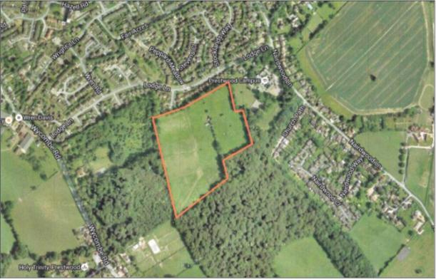

Figure 1. Proposed site for a new combined school.

4. Improvements to the Public Realm via Community Infrastructure Levies

The introduction of CILs from new development is supported. To enable revitalisation projects, such as town centre redesigns and road improvement schemes, developers of larger projects need to make contributions via a Community Infrastructure Levy or investment in projects so that new development is a benefit to all.

Within the 2018 refresh of the Community Vision for the Parish, the top priority for local improvements is improvements to public space, closely followed by improvements to the appearance of villages.⁵

Projects such as the redesign of Prestwood Village Centre could be made possible if CIL funding from development within the district could be available to fund it.⁶

- Communications referencing the issues related to the existing schools go back several years. The suggestion to consolidate the schools received support from the headteacher.
⁵ http://www.gmprg.org.uk/current-projects/community-vision/
⁶ http://www.gmprg.org.uk/current-projects/prestwood-village-revitalisation/
4
GMPRG Response Submitted 11 February 2022
Great Missenden & Prestwood Revitalisation Group

Incorporating Ballinger, South Heath and Heath End

- Other general comments

  - Redevelopment of the current Paradigm social housing in Hazell Road is supported. From plans drawn up locally, this site could provide twice the amount of sustainable and better designed dwellings. ⁷

  - Existing business and employment sites should be retained or increased in order to give a full range of services to the large population of Prestwood and local employment.

  - Any new development (the Prestwood Centre Improvement Project ⁸ ) needs to provide adequate parking and contributions to public realm improvements.

  - Specific provision for cycle routes should be encouraged – especially linking Great Missenden to Prestwood and Wendover to Great Missenden and Amersham, to improve connectivity and encourage commuters to cycle rather than driving and parking in Great Missenden. ⁹

  - Improved provision for recharging of electric cars and cycles.

  - Improvements to services and infrastructure that are needed for Prestwood include a bus service that accesses Amersham, Stoke Mandeville and Wycombe Hospitals and more regular and direct services on existing bus routes.

  - Both Prestwood and Great Missenden have parking problems. Ways to alleviate them could be a community shuttle bus to/from Great Missenden station for commuters and the promotion of car share schemes and subsidised improvements to public transport. ¹⁰

  - Nature conservation sites to encourage biodiversity and safeguard local rare plant and bird species and protect wildlife habitats should be identified and listed in the Local Plan.

  - Guidelines to improve the protection of existing trees and hedges, but also, appropriate types of trees and landscaping for the Chilterns Area of Outstanding Natural Beauty should be included in the Local Plan.

  - Planning for new development should consider a broad community plan to link ‘places of meaning’ using accessible cycle routes and footpaths. Ecologically sustainable improvements to existing routes need to be included as part of this consideration.¹¹

  - Continued the next page

- Cllr Peter Martin et al. have met with Paradigm to discuss this project in 2015. While Paradigm could not commit to the project immediately, they acknowledged the need to improve the physical appearance and layout of some of the older estates such as Hazell Village. See local plan submission March 2016 [pp. 1-3] ⁸ http://www.gmprg.org.uk/current-projects/prestwood-village-revitalisation/

⁹ Cycleway from Prestwood to Great Missenden Extracts from DDPD August 2014.
¹⁰ The GMPRG Transport Sub-Group were in the process of engaging the community to determine ways in which we could reduce traffic congestion and parking locally to make our villages safer and cleaner. The initiative was derailed by the COVID-19 Pandemic.

¹¹ Creating a safe and quiet route for children walking to the Misbourne School in Great Missenden from Prestwood has been considered. The improvement of existing rights of way between the two communities include improvements to two paths.
5

GMPRG Response Submitted 11 February 2022
Great Missenden & Prestwood Revitalisation Group

Incorporating Ballinger, South Heath and Heath End

- Prestwood Common to stay a Local Green Space with improved buildings and more sports and play facilities in line with CDC Open Spaces Strategy. ¹²
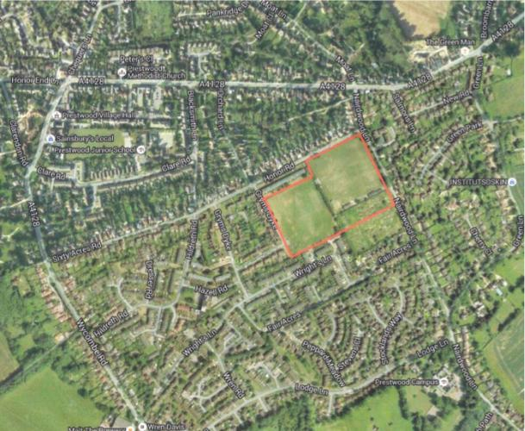

Figure 2. Location of Local Green Spaces in Prestwood.

- Development Standards

a. Protection of the highly valued Natural infrastructure.

Previous community consultations show that the residents of Prestwood and Great Missenden highly value their beautiful surroundings. Being part of a designated ‘Area of Outstanding Natural Beauty’ is an intrinsic part of our community identity. Protecting high value natural infrastructure such as boundary hedges, grass verges, trees and shrubs is considered a critical part of retaining our sense of place, while ensuring we do not further degrade the important continuity of our ecological systems or challenge our efforts to strengthen our local natural biodiversity.

b. New builds encouraging water consumption reduction

There is considerable concern about the supply of water in the Great Missenden area. Water is mainly taken from the aquifer under the Misbourne Valley. This aquifer is also the source of water for the River Misbourne, a globally rare chalk stream. The recharge of water to the aquifer is from rainfall, and as such is unpredictable. Affinity Water have given undertakings to reduce abstraction to protect chalk streams in the Chilterns. Thus, with further development the supply of water is under threat. There are alternatives such as reducing water usage. We submit that the Local Plan should encourage a reduction in water consumption through:

- https://www.chiltern.gov.uk/open-space-strategy
6

GMPRG Response Submitted 11 February 2022
Great Missenden & Prestwood Revitalisation Group

Incorporating Ballinger, South Heath and Heath End

- All new properties being required to install ‘grey’ water systems, where wastewater from baths and showers is collected, filtered, disinfected, and then used for toilet flushing. This can reduce water usage by up to 50%.
- All new properties install water butts for rainwater collection.

- Encouraging all households

  - to install water butts for water for the garden o restrict the use of sprinklers and power washers

- Prestwood Canopy

Communities all over the UK are aligning with government and regional efforts to reduce the impact of Climate Change by adopting tree planting initiatives.

The Buckinghamshire Council are supporting this initiative through the release of a new programme (Apply to plant a tree on council land, 2021). The programme provides a way for the public to suggest locations for trees to be planted within roadsides and verges that are managed and maintained by the Council. A successful application will include support for:

- The licencing process for undertaking tree planting

- The location of services and digging
- Insurance (Public Liability)
- Requirements for tree planting works.
- Selecting the right species and variety (right tree and right location).

The Buckinghamshire Council cites the benefits of building ‘Green Infrastructure in the following way:

- reducing flood risk and improving air & water quality

- mitigating the causes and impacts of climate change such as global warming
- living spaces for communities
- productive landscapes for growing food
- recreation, and proven benefits for health and wellbeing
- provides areas for wildlife to thrive
- opportunities for enjoyment of culture, heritage and landscape

(Green infrastructure | Buckinghamshire Council, 2021)

According to the Forestry Commission Map Browser, large areas of Prestwood are under 0-9% while others only enjoy the benefit of 10-20% mixed average canopy cover meaning that many of the benefits of ‘green infrastructure’ will be reduced in the Prestwood Community. Great Missenden by contrast is assessed at 20%+ average canopy cover. The GMPRG proposes that the local plan be focused on increasing the canopy coverage in Prestwood, mitigating against flood risk and other impacts of climate change. The local plan should be

7

GMPRG Response Submitted 11 February 2022
Great Missenden & Prestwood Revitalisation Group

Incorporating Ballinger, South Heath and Heath End

designed with the intention of increasing the overall Prestwood canopy coverage to exceed 20% in 10 years. This will improve community resilience against the anticipated impacts of climate change and contribute to national carbon sequestration initiatives.
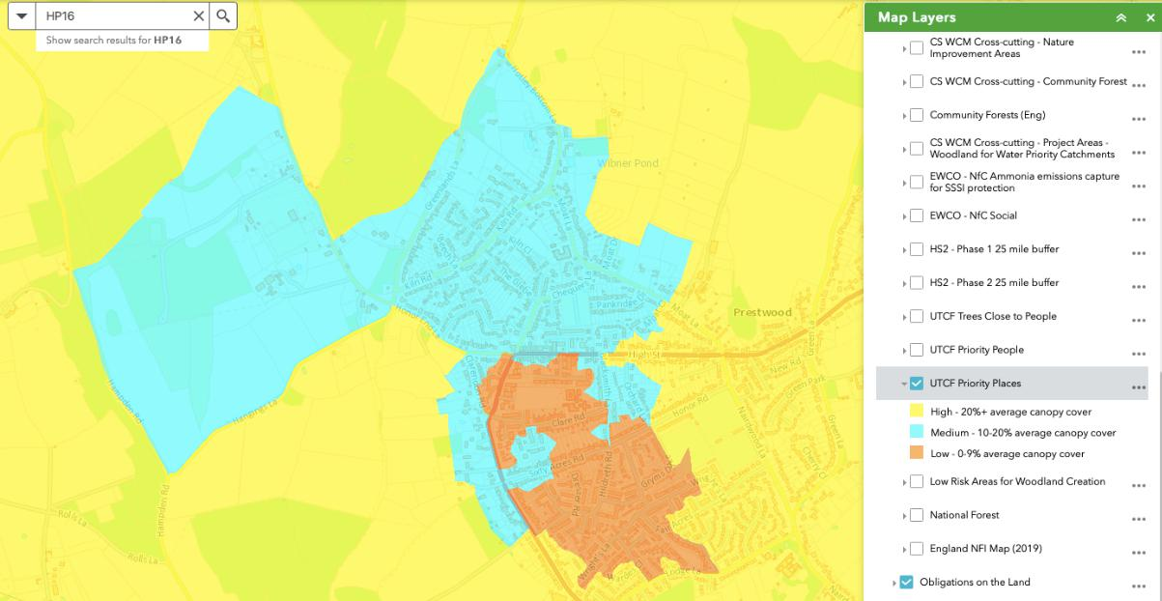

(ArcGIS Web Application, 2021) - HP16 - UTCF Priority Places

8

GMPRG Response Submitted 11 February 2022

